Football Team Logo Classification Using CNNs

Borjan Petrevski, Hristijan Gjoreski
Faculty of Electrical Engineering and Information Technologies,
University of Ss. Cyril and Methodius in Skopje, Macedonia
boki.borjan012@gmail.com, hristijang@feit.ukim.edu.mk

Abstract— This study explores the use of Convolutional Neural Networks (CNNs) for automatic classification of football team logos, which is an interesting computer vision task, because of the different variations in color, shape, orientation and design across all of the teams in the dataset. The project mostly focuses on multi-class image classification using Deep Learning, precisely Convolutional Neural Network (CNN). The CNN model is first trained from scratch on official La Liga football team logos to learn general visual features. To improve generalization and reduce overfitting, various data preprocessing techniques were used such as image resizing, normalization and data augmentation, along with regularization methods including dropout and early stopping callbacks. After training the baseline model on the La Liga dataset, transfer learning was used by using the convolutional layers of the La Liga model as a fixed feature extractor for classifying Serie A dataset, while the pretrained convolutional layers were frozen. Model performance was evaluated using accuracy, confusion matrix and classification reports. The transfer learning approach achieved high accuracy of approximately 97% on the Serie A test set. There could also be a debate if this indicates overfitting or if it demonstrates that CNNs can effectively learn and transfer visual features even from relatively small pictures and dataset and show such high results.
I. INTRODUCTION
Image classification has become an important task in computer vision, with usage in areas such as object recognition, brand identification and sport analytics [2]. One specific and interesting problem is football team logo classification. Football logos are distinctive visual symbols, but they differ in color, shape, orientation, resolution and artistic style. The main question made in this study is whether Convolutional Neural Networks (CNNs) can effectively learn and generalize visual features of football team logos and whether knowledge learn from one football league can be transferred to another.
The question is important because logo recognition represents real-world vison problem where datasets are often limited in size and visual diversity [1]. Traditional image-processing approaches rely on handcrafted features, who often fail to capture complex patterns. CNNs, on the other hand with the current development with AI, have shown strong performance in image classification tasks by learning feature maps directly from raw pixel data [1]. Exploring their effectiveness for football logo classification helps demonstrate how deep learning can be applied to structured visually complex designs.
To address this problem, this project uses CNN-based approach combined with Transfer Learning. First, a baseline CNN model is trained from scratch using official La Liga team logos dataset. The model learns general visual features such as shapes, colors, and emblem structures. Before training, all images are resized and normalized, and data augmentation techniques such as rotation, translation, zooming, and flipping are applied to improve generalization and reduce overfitting. After training the baseline model, transfer learning is applied by reusing the convolutional layers of the La Liga model as a fixed feature extractor for classifying Serie A team logos. A new classification head is added, while the pretrained convolutional layers are frozen to preserve learned features.
The transfer learning model achieves high classification accuracy on the Serie A dataset, demonstrating that CNNs can successfully transfer learned visual knowledge between different football leagues. However, given the relatively small size of the dataset, these high results also raise the question of whether the model’s performance reflects true generalization or if it is partly influenced by overfitting. This highlights an important aspect of evaluating deep learning models on limited data and leaves room for further analysis and future investigation.
II. RELATED WORK
Image classification using deep learning has been extensively studied in recent years, with Convolutional Neural Networks (CNNs), becoming the most dominant approach for visual recognition tasks. CNN-based image classification demonstrated that deep neural networks can significantly outperform traditional machine learning methods that rely on handcrafted features. Since then, CNNs have been successfully applied to a wide range of computer vision problems, including object recognition, face detection and logo classification [3].
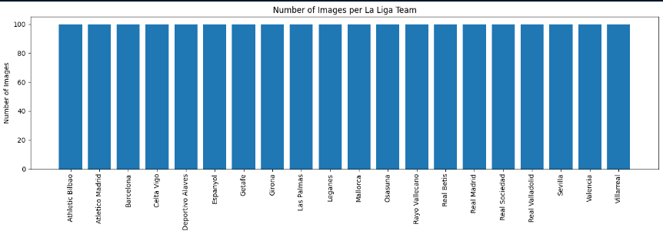
Several studies have shown that CNNs are particularly effective at learning visual features from images. Lower layers typically learn simple patterns such as edges and textures, while deeper layers capture more complex structures and shapes. This ability makes CNNs well suited for logo recognition tasks, where visual elements such as colors, symbols, and geometric shapes play a crucial role. Previous research has applied CNNs to logo and brand recognition, achieving strong performance even in cases where logos vary in size, orientation, and design style [5].
Transfer learning has emerged as a widely used technique to address the challenge of limited training data. Instead of training a model entirely from scratch, pretrained CNNs are reused as feature extractors for new but related tasks. Studies have shown that features learned on one dataset can often be transferred successfully to another dataset, especially when both datasets contain similar visual characteristics. This approach reduces training time and improves performance, particularly in small or medium-sized datasets, which are common in real-world applications such as logo classification [6].
Despite the success of CNNs and transfer learning, several works emphasize the importance of careful evaluation when working with small datasets. High classification accuracy does not always guarantee strong generalization, as deep learning models can sometimes memorize training data rather than learn transferable features.
This study applies CNN-based image classification and transfer learning to the specific problem of football team logo recognition. By training a CNN on La Liga logos and transferring learned features to classify Serie A logos, this work follows established deep learning practices while exploring how effectively visual knowledge can be transferred between different football leagues.
III. DATA
This study uses two image datasets consisting of official football team logos from two major European leagues: La Liga and Serie A. The datasets are organized in a class-based folder structure, where each folder corresponds to a single football team and contains multiple logo images of that team. Each team represents one class in a multi-class image classification problem.
The La Liga dataset is used to train a baseline Convolutional Neural Network (CNN) model from scratch. It contains logos from Spanish football clubs, with each class having a similar number of images. This relatively balanced class distribution helps prevent bias toward specific teams during training. However, despite being balanced [Fig. 1], the dataset is limited in overall size, which makes the learning task more challenging and increases the risk of overfitting.
Figure 1: Class Distribution (Bar Chart)
After training the baseline model, a second dataset containing Serie A football team logos is used to evaluate transfer learning. This dataset follows the same structure as the La Liga dataset, with one folder per team. To ensure proper evaluation and avoid data leakage, the Serie A dataset is manually split into training, validation, and test subsets. The training set is used to train the new classification head, the validation set is used for monitoring performance during training, and the test set is reserved exclusively for final evaluation.
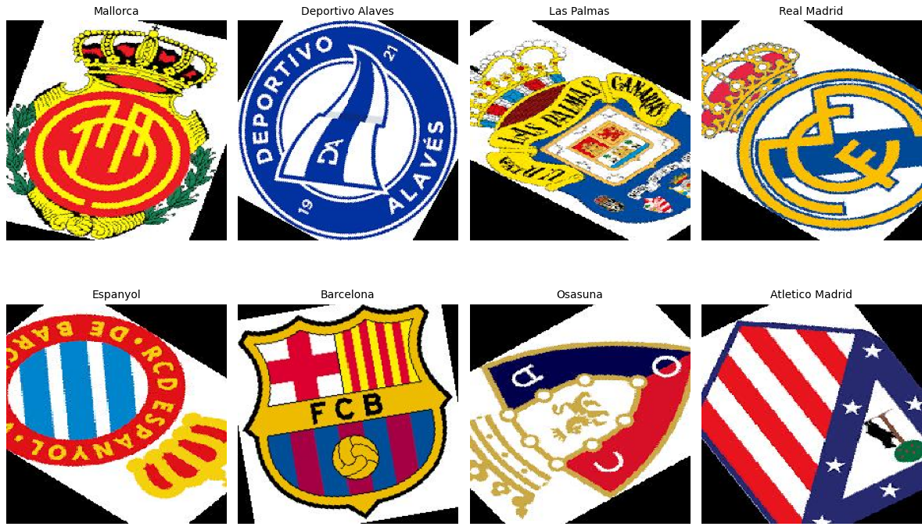
Figure 2: Images before rescaling
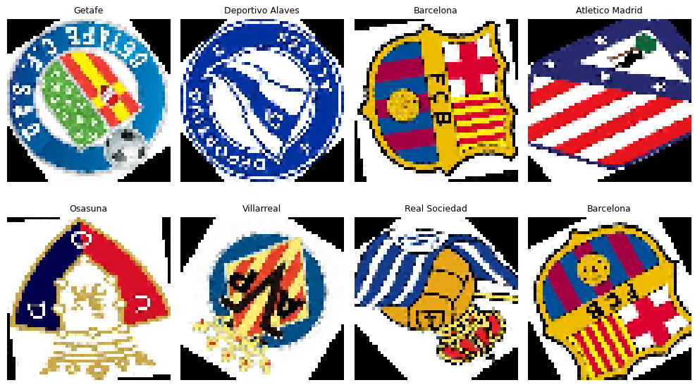
Before training, all images from both datasets undergo preprocessing. Original logo images vary in resolution, aspect ratio, and visual quality. To ensure consistency and compatibility with the CNN architecture, all images are resized to a fixed resolution of 56 × 56 pixels and normalized so that pixel values lie within the range [0, 1]. This preprocessing step reduces computational complexity while preserving essential visual features such as shapes, colors, and emblem structures.
Figure 3: Images after rescaling
To improve model robustness and mitigate overfitting caused by the small dataset size, data augmentation is applied to the training data. Augmentation techniques include random rotations, translations, zooming, shearing, and horizontal flipping. These transformations artificially increase data diversity and help the model become invariant to changes in orientation and scale that commonly occur in real-world logo images.
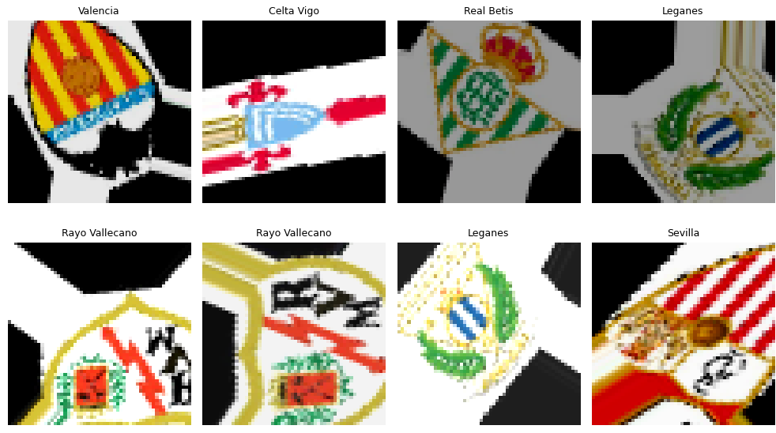
Figure 4: Images after applying Data Augmentation
Although both datasets are balanced in terms of class distribution, their limited size remains an important factor when interpreting experimental results. High classification accuracy achieved on small datasets may indicate strong feature learning, but it may also raise concerns about overfitting. For this reason, careful dataset splitting, augmentation, and evaluation strategies are essential, and the results seen in later sections should be interpreted with these limitations in mind.
IV. METHODS
This section describes the methodology used to perform football team logo classification using Convolutional Neural Networks (CNNs) and transfer learning. The solution consists of data preprocessing, baseline CNN training on the La Liga dataset, application of data augmentation and regularization techniques, and transfer learning to classify Serie A team logos.
All logo images were first preprocessed to ensure consistency across datasets. Images originally varied in size, resolution, and aspect ratio. To make them suitable for CNN input, all images were resized to a fixed resolution of 56 × 56 pixels. Pixel values were normalized to the range [0, 1] to stabilize training and improve convergence. The same preprocessing steps were applied to both La Liga and Serie A datasets to maintain consistency.
A baseline CNN model was designed and trained from scratch using the La Liga dataset. The network consists of multiple convolutional layers followed by max-pooling layers, which are responsible for extracting spatial and visual features from the input images. These layers are followed by fully connected (dense) layers that perform the final classification. Rectified Linear Unit (ReLU) activation functions are used throughout the network to introduce non-linearity, while a softmax activation function is applied in the output layer to produce class probabilities.
To reduce overfitting, dropout layers are included in the fully connected part of the network. This baseline model serves as the foundation for subsequent transfer learning experiments.
The baseline CNN is trained using the La Liga dataset with categorical cross-entropy as the loss function, which is appropriate for multi-class classification problems. Model optimization is performed using the Adam optimizer. Training is monitored using a validation set, and early stopping is applied to prevent unnecessary training once validation performance stops improving. Model checkpointing is used to save the best-performing model based on validation accuracy.
To improve generalization and address the limited size of the dataset, data augmentation is applied to the training data only. Augmentation techniques include random rotations, translations, zooming, shearing, and horizontal flipping. These transformations help the model become invariant to changes in orientation, position, and scale that commonly occur in real-world logo images. The augmentation process follows standard practices commonly used in CNN-based image classification.
After training the baseline CNN on the La Liga dataset, transfer learning is applied to classify Serie A team logos. The convolutional layers of the trained La Liga model are reused as a fixed feature extractor. These layers are frozen to preserve the learned visual representations. The original classification head is removed and replaced with a new classification head consisting of a flattening layer, a dense layer with ReLU activation, a dropout layer, and a final softmax layer corresponding to the number of Serie A classes.
Only the newly added classification head is trained on the Serie A training dataset, while the pretrained convolutional layers remain unchanged. This approach reduces training time and allows the model to leverage previously learned visual features.
V. EXPERIMENTAL SETUP
The experimental setup is designed to fairly evaluate both the baseline CNN model and the transfer learning approach while minimizing data leakage and overfitting. For the baseline experiment, the La Liga dataset is divided into training and validation subsets. The training set is used to learn the model parameters, while the validation set is used to monitor performance during training and to determine when to stop training using early stopping. This setup helps ensure that the model does not simply memorize the training data.
For the transfer learning experiments, the Serie A dataset is manually split into three parts. Seventy percent of the data is used for training the newly added classification head, fifteen percent is used for validation, and the remaining fifteen percent is reserved as a test set. The test set is not used during training or model selection and is kept separate to provide an unbiased evaluation of final model performance. This splitting strategy is important to ensure that reported results reflect the model’s ability to generalize to unseen data.
Data augmentation is applied only to the training data during both baseline and transfer learning experiments. Augmentation is disabled for validation and test sets to ensure that performance metrics reflect true generalization rather than artificially modified samples. This separation ensures a fair and reliable evaluation of the trained models.
Model performance is evaluated using standard multi-class classification metrics. Accuracy is used as the primary metric to measure the proportion of correctly classified samples. In addition, confusion matrices and classification reports are used to analyze class-wise performance in more detail. Accuracy is defined as the ratio of correctly classified samples to the total number of samples, taking into account true positives, true negatives, false positives, and false negatives. Together, these metrics provide a comprehensive view of overall performance and potential weaknesses in classification behavior.
VI. EXPERIMENTAL RESULTS
The learning behavior of the baseline CNN model trained on the La Liga dataset is illustrated through the training and validation accuracy curves shown in Figure 5. As training progresses, training accuracy increases steadily, while validation accuracy follows a similar overall trend. Although the gap between the two curves remains relatively small for most of the training process, the limited size of the dataset makes it difficult to fully rule out overfitting. As a result, while the observed trends suggest that the model is able to learn relevant visual features, the possibility that the model partially adapts to the training data cannot be excluded.
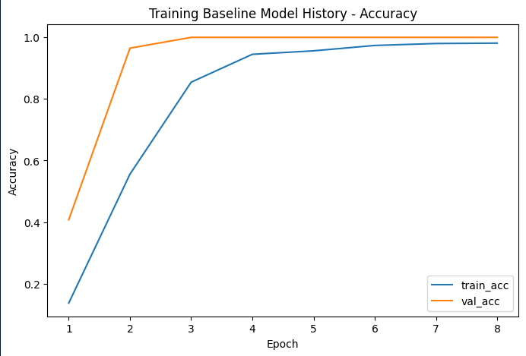
Figure 5: Training Baseline Model – Accuracy Curve
The performance of the transfer learning model is evaluated on the held-out Serie A test set, and the resulting confusion matrix is shown in Figure 6. Most classes are correctly classified, as indicated by strong diagonal values, while only a small number of misclassifications occur between teams with visually similar logos. This demonstrates that the pretrained convolutional layers are able to extract discriminative features that generalize well across different football leagues.
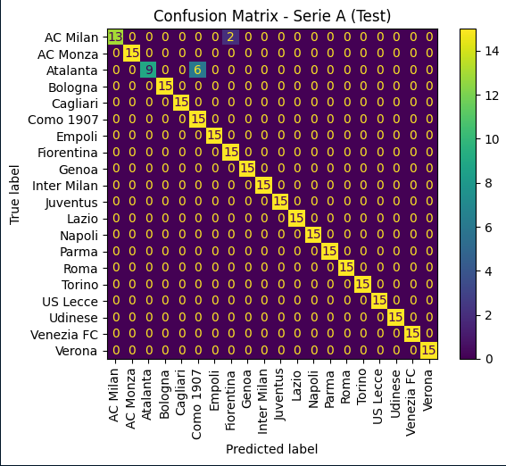
Figure 6: Confusion Matrix for the Test-Set
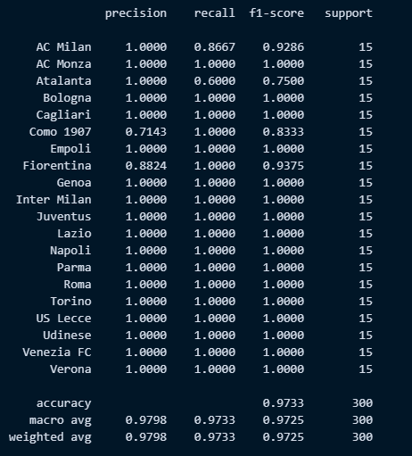
In addition to the confusion matrix, the classification report confirms strong performance across precision, recall, and F1-score metrics for most classes. Overall test accuracy reaches approximately 97%, indicating highly effective classification under the chosen experimental setup. Sample predictions shown in Figure 7 further illustrate the model’s ability to correctly identify team logos under varying visual conditions. At the same time, the relatively small dataset size introduces some uncertainty regarding the model’s generalization capability, leaving open the question of whether the observed performance reflects exceptional feature learning or potential overfitting.
Figure 7: Classification Report
VII. CONCLUSION
In this project, I explored the use of Convolutional Neural Networks (CNNs) for the task of football team logo classification, with a particular focus on transfer learning between different football leagues. By training a CNN model on La Liga team logos and reusing the learned visual features to classify Serie A logos, I aimed to examine whether knowledge learned from one dataset could be effectively transferred to another related task. The experimental results show that the model is capable of achieving high classification accuracy, indicating that CNNs can successfully capture distinctive visual patterns such as shapes, colors, and emblem structures present in football logos.
At the same time, it is important to critically evaluate these results in the context of the dataset used. Although the datasets are balanced across classes, their overall size is relatively small. This introduces uncertainty regarding the model’s ability to generalize to unseen data beyond the available samples. While the strong performance may suggest effective feature learning and successful transfer of visual knowledge, it is also possible that the model partially adapts to specific characteristics of the training data, which may indicate a degree of overfitting. Based on the available experiments, it is not possible to definitively distinguish between these two explanations.
Despite these limitations, the project demonstrates that combining CNNs, data augmentation, and transfer learning provides a practical and efficient approach for logo classification tasks when data is limited. The results highlight both the potential and the challenges of applying deep learning methods to small, specialized datasets. Overall, this work serves as a foundation for future studies that could further investigate model generalization by using larger datasets, incorporating logos from additional leagues, or fine-tuning deeper layers of the network. Such extensions would help clarify whether the observed performance reflects robust generalization or dataset-specific behavior.
REFERENCES
[1] LeCun, Y., Bengio, Y., & Hinton, G. (2015) Deep Learning
[2] Krizhevsky, A., Sutskever, I., & Hinton, G. (2012) ImageNet Classification with Deep Convolutional Neural Networks
[3] Zeiler, M. D., Fergus, R. (2014) Visualizing and Understanding Convolutional Networks ECCV 2014
[4] Bianco, S., Buzzelli, M., Mazzini, D., Schettini, R. (2017) Deep learning for logo recognition Neurocomputing
[5] Eggert, C., Brehm, S., Winschel, A., Zecha, D. (2015)Logo Recognition in Real-World Images Using Deep Neural Networks ICPR 2015
[6] Yosinski, J., et al. (2014) How transferable are features in deep neural networks? NeurIPS

